

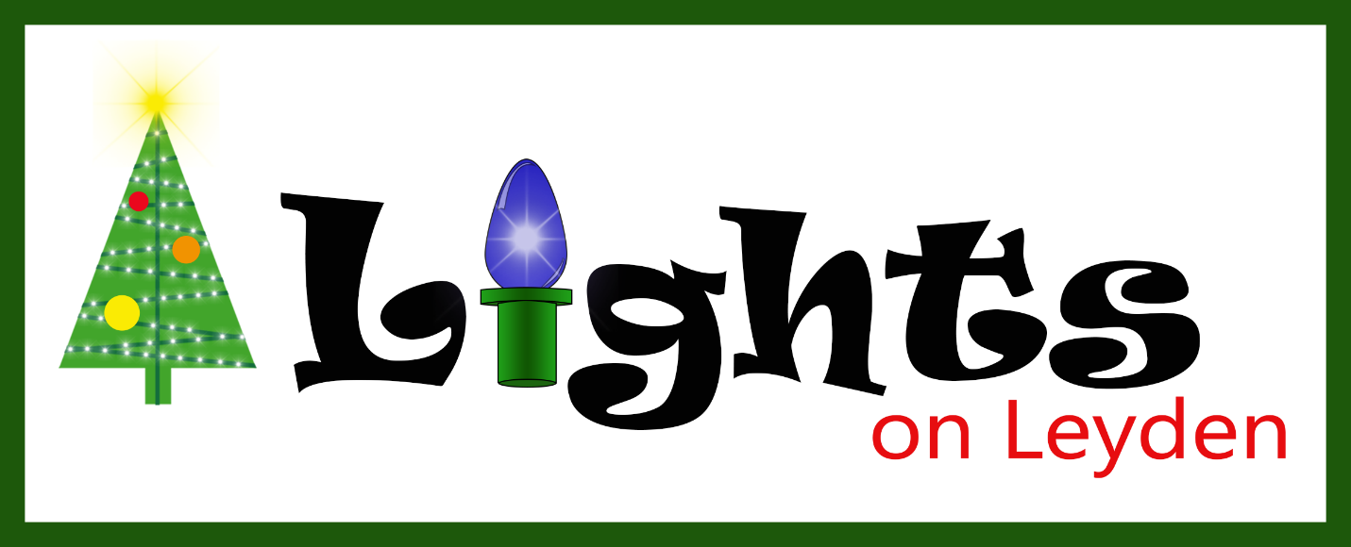



**Wreath**

Are you counting the days to Christmas?

The wreath was one of the first items in the display. It was purchased from Hobby Lobby. It was later rebuilt with a Christmas Countdown Clock. It was rebuilt again with a different countdown clock. And finally, the newest one has the latest electronics in it that gives the beautiful images.

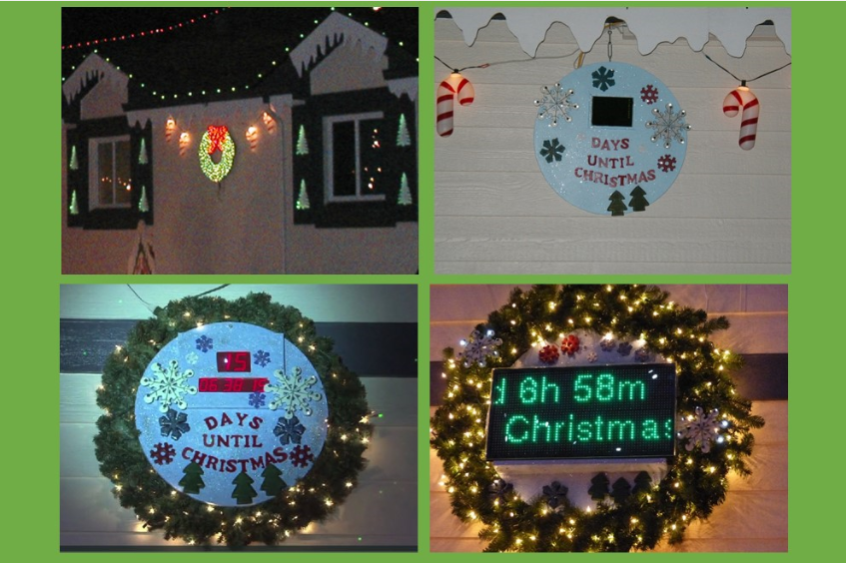

**Reindeer**

Don’t forget to look up to see Santa’s sleigh and reindeer!

The reindeer was one of the first items built for the display. It first hung off the deck of our apartment before we moved to house on Leyden Street. My brother helped me cut out the shapes. The reindeer rack was first displayed in the yard and later moved to the roof. In 2010 we debuted new 3-dimensional reindeer and sled. In 2017 we created new reindeer that are made from a special Paper Mache recipe and colored to be more life-like.

.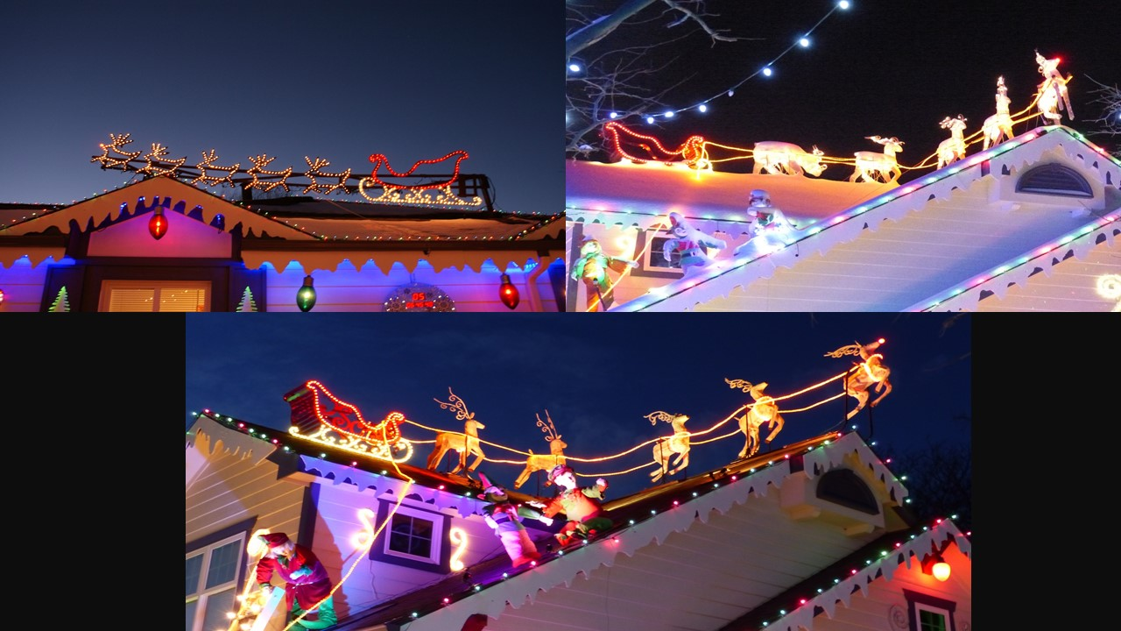

**Dwarf Spruce Tree**

We planted this tree in 1994. It held only 150 lights because it was so small. As it grew, the number of lights increased and eventually we added the star on top. Since 2016 the tree has been adorned with 900 RGB pixel globes.

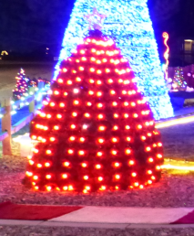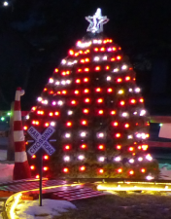

**Penguins**

The skating penguins and ice patch were built in 1999. The penguin sound came from a stuffed animal.

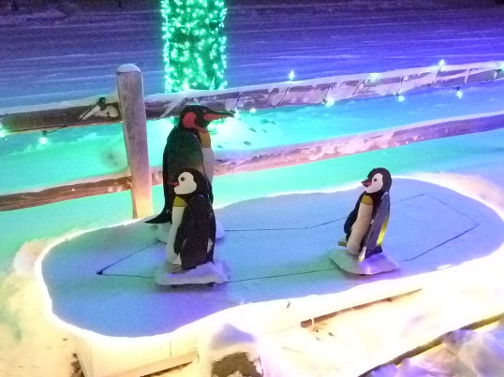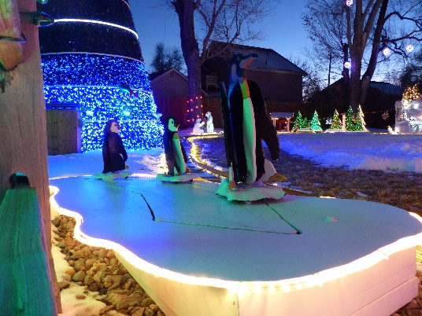

**Magic Tree**

The original magic tree was a beautiful Colorado blue spruce that we planted in 1993. In 2006 we started the animated magic show on the tree, decorating it with red and blue bulbs and white rope lights. It grew every year until it supported over 90,000 lights. Unfortunately the tree died in 2017 and we replaced the tree with what you see today. It supports 138,519 LED lights with the new colorful light rings and curls.

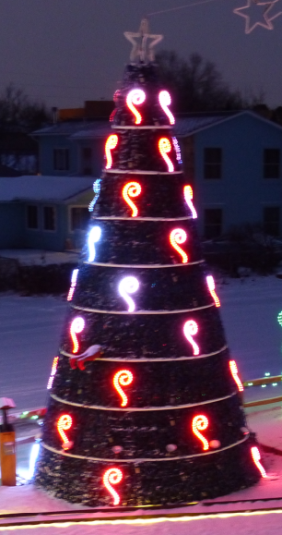 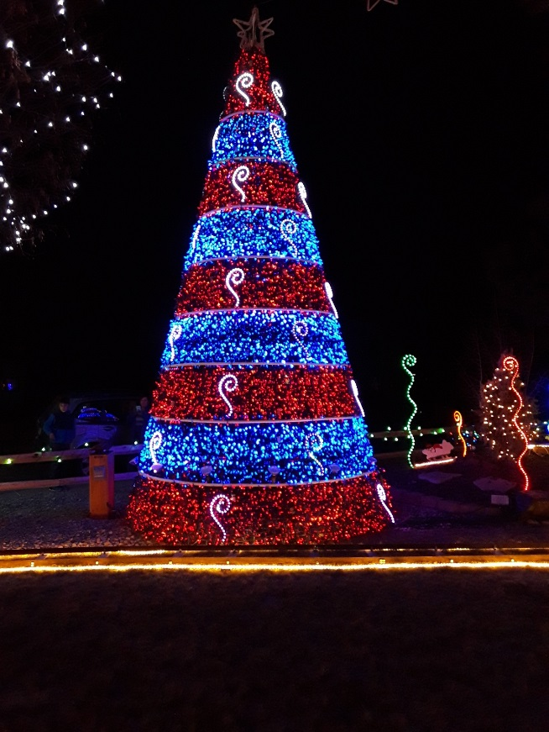

**Candy Canes**

The candy canes were first built in 1994 and held 135 lights each. They were rebuilt in 1999 and held 500 lights each. Finally, they were rebuilt in 2010 to the current size.

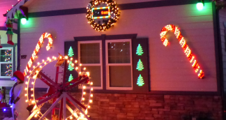

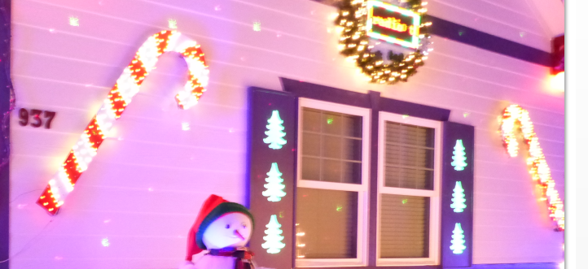

**Stockings**

Two stockings were built in 1995, one for Kelli and one for Tim. In 1997 we added one for Jeremy as a new addition to the family.

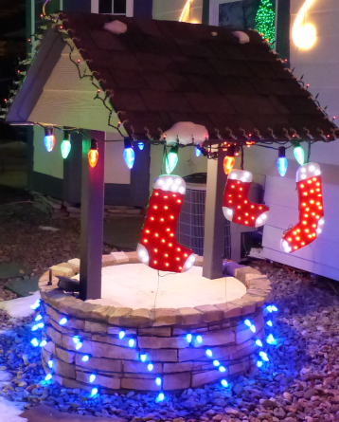

**Christmas Tree and Packages**

This feature was created in 1995. The tree was rebuilt to a larger version in 1998, then rebuilt again in 2009. The packages use a color organ that Tim created in high school. They were rebuilt in 2005 with colorful Plexiglas.

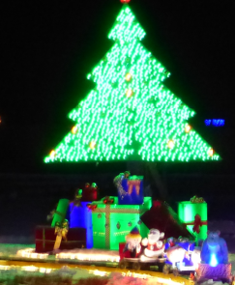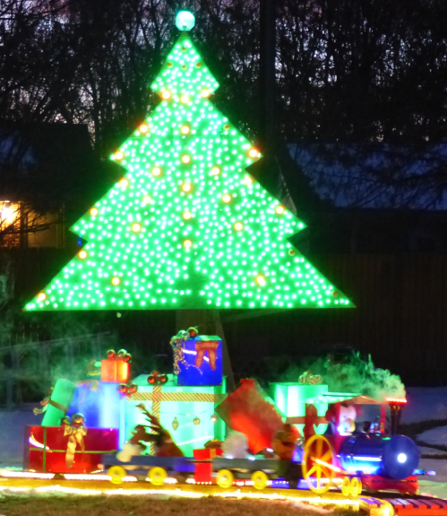

**Snowman and Snow Lady**

The Snowman was originally built in 1996 and the Snow Lady was built in 1997. Both were built using Winfield patterns, but were modified for the Snowman to tip his hat and the Snow Lady to swing her broom.

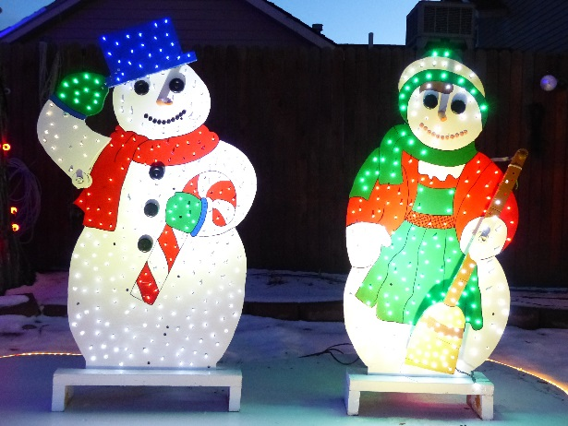

**Santa Claus**

Santa has been one of our favorite pieces. The first Santa version was a cut out made from Winfield Patterns in 1993. He was modified to have a waving arm by blinking lights from one are to the next. The next Santa was also from a Winfield pattern, built in 1997. We built a ladder that has mechanics for Santa to “climb” the ladder. In 2005 we upgraded Santa to a life-sized 3D model. We added life-like movement in the head, mouth, and arms. We added sound - Kelli’s dad became the voice of Santa. Over the years we have replaced the beard and costume and continually work on him to be more and more life-like.

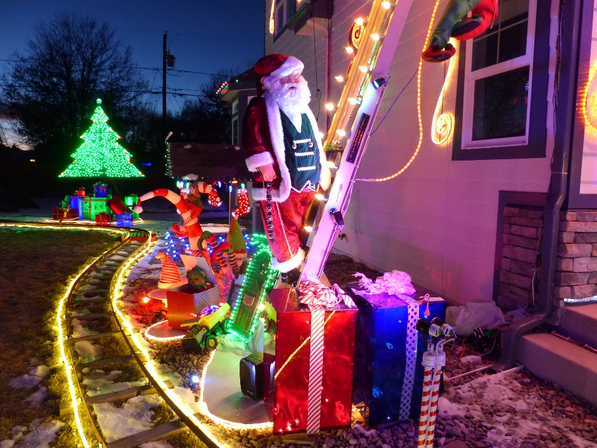

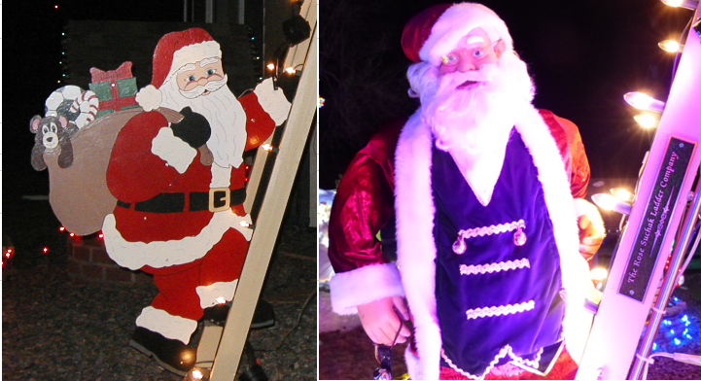

**Train**

The very first train was built in 1996. The track was made out of plywood and went around the Snowman and Snow Lady. In 2000 we created a new larger train with real looking train track with rails and railroad ties. This track went from the front berm to the mountain, and the train moved back and forth. In 2001 we add more track so the train could loop around the yard. Over the years the train has been updated with new features and new electronics.

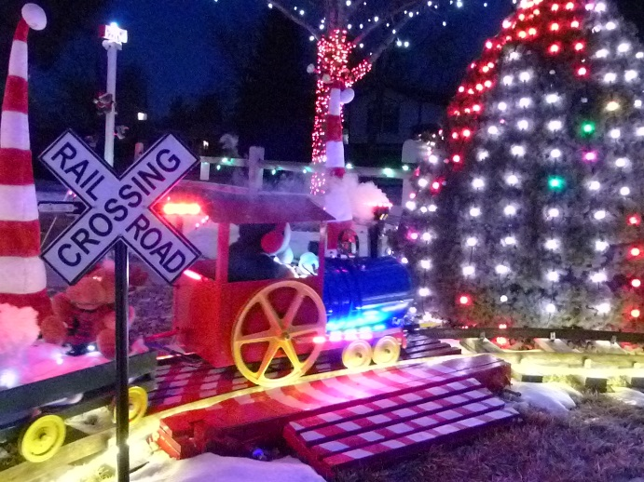

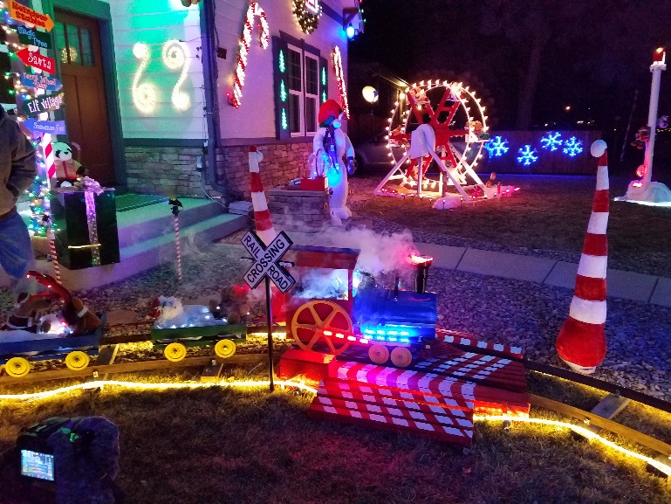

**Elves**

The homemade elves have been part of the display since 2005. Over the years we have added more of these little helpers, including the falling elf that hangs from the front porch.

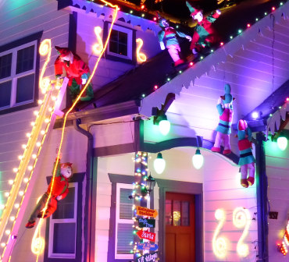

**Mountain and ski tow**

The first mountain was created in 1998 to provide a place for the train to park and be protected from the weather. Over the years the design for the teddy bear skiers have changed, but the mountain features skiers, sledders, lights, and trees.

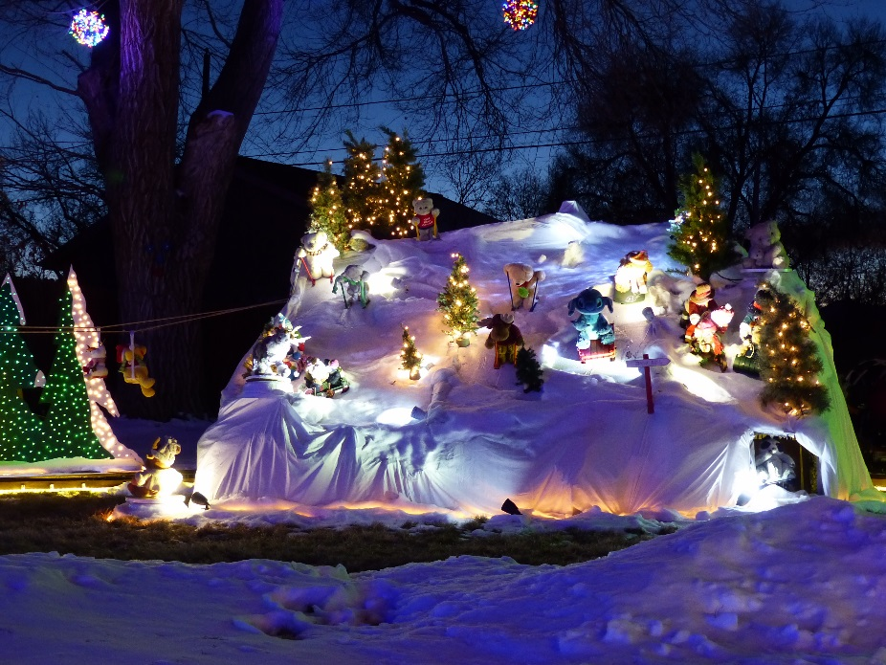

**Bumbles**

Bumbles the snow monster was inspired by our then 6 year old. He envisioned it jumping up from behind the mountain and roaring. Bumbles has been part of the display ever since.

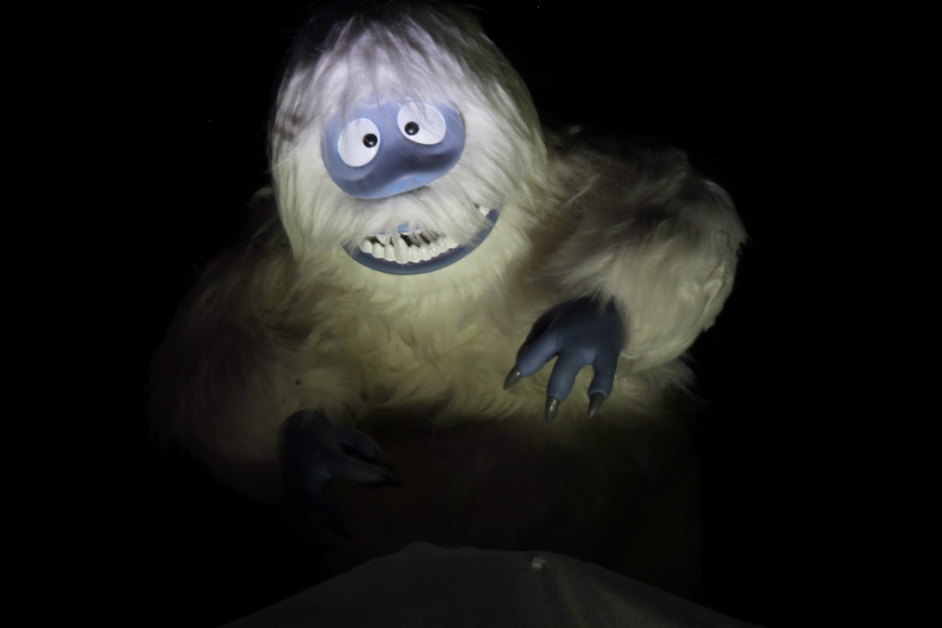

**Polar Bears**

The Polar Bears were built in 1996 from a Winfield pattern, but were modified to add movement. Everyone referred to them as the Coke-a-Cola bears, so we added the Coke bottles to the package they hold.

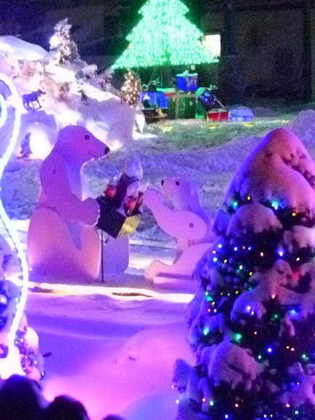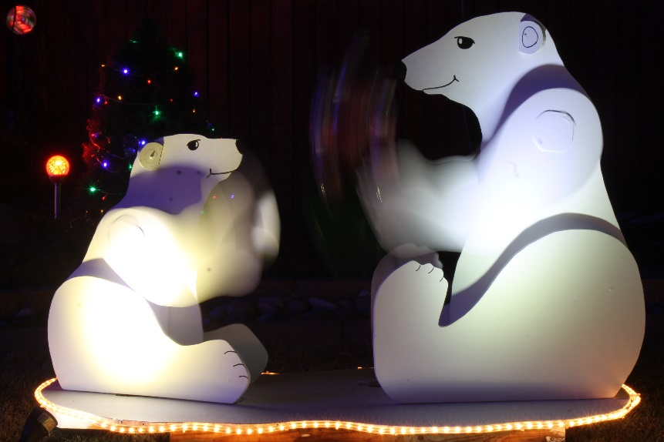

**Ferris Wheel**

The Ferris wheel is completely home-made. It was introduced into the display in 2007. It features its own light show and teddy bears enjoying the ride.

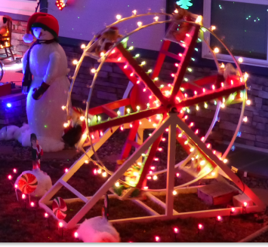

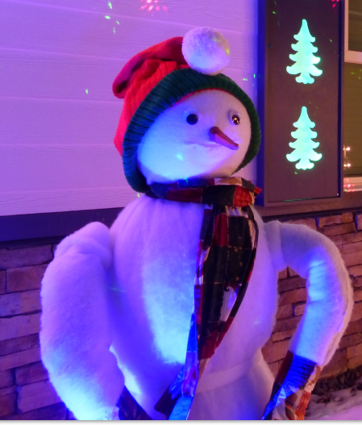

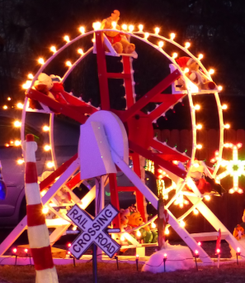

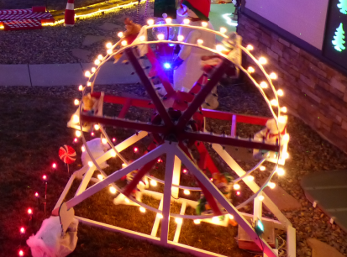

**The Grinch**

Is his heart two sizes too small?

The Grinch is a video clip from the movie that shows him peeking out the window and watching you!

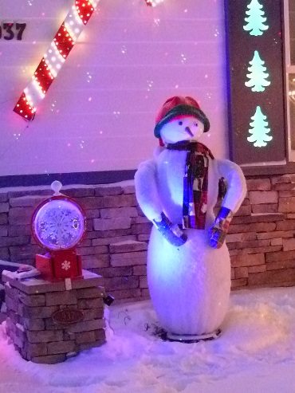

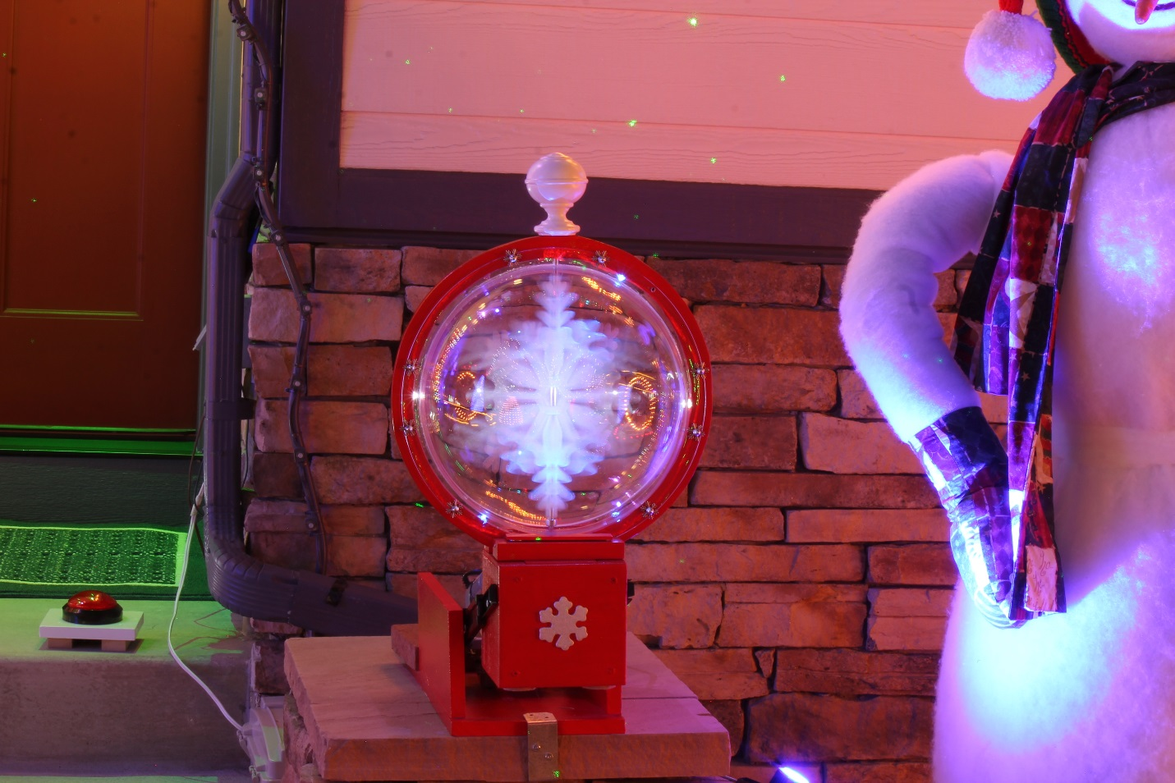

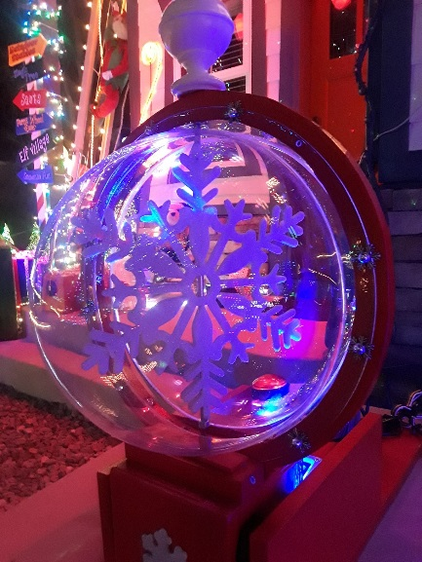

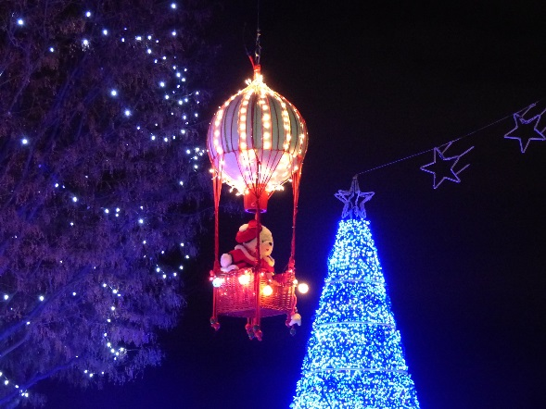

Oak Tree

Planted in 1995.

Locust Tree

Planted in 1995.

Parade started in 2005

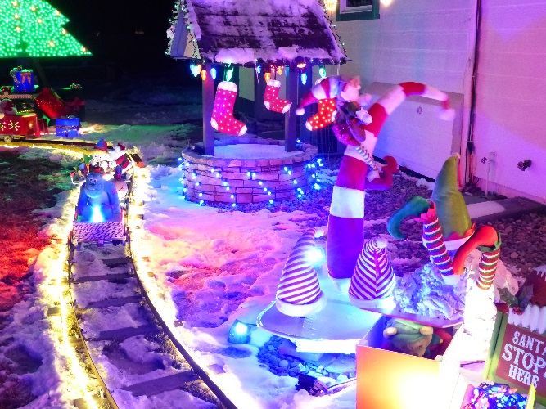

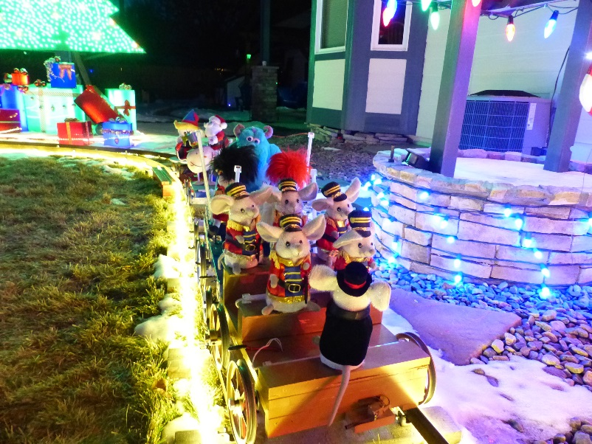

For the Geeks some technical aspects of the display